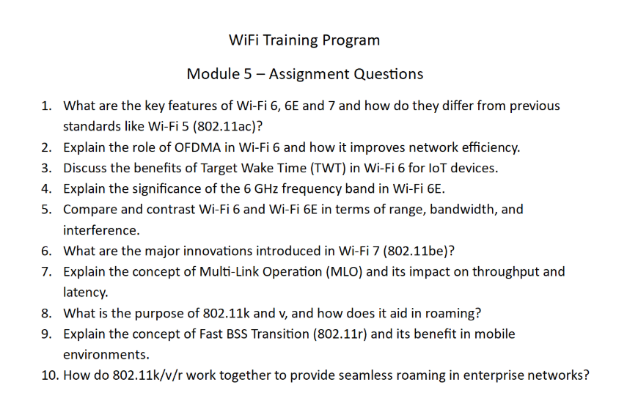

Wi-Fi Training Program
Assignment – Module 5

1. Key Features of Wi-Fi 6, 6E, and 7 and Differences from Wi-Fi 5
Wi-Fi 5 (802.11ac):
- Operates in 5 GHz band
- Uses OFDM
- Supports MU-MIMO (downlink only)
- Max speed ~6.9 Gbps
Wi-Fi 6 (802.11ax):
- Operates in 2.4 & 5 GHz
- Introduces OFDMA (multi-user efficiency)
- Supports uplink and downlink MU-MIMO
- Improved battery efficiency (TWT)
- Better performance in dense environments
Wi-Fi 6E:
- Extends Wi-Fi 6 into 6 GHz band
- Provides more channels and less interference
Wi-Fi 7 (802.11be):
- Supports 320 MHz channels
- Introduces Multi-Link Operation (MLO)
- Uses 4096-QAM for higher data rates
- Ultra-low latency and high throughput
Explanation:
Each generation improves speed, efficiency, and ability to handle more devices simultaneously.

2. Role of OFDMA in Wi-Fi 6
OFDMA (Orthogonal Frequency Division Multiple Access) divides a channel into smaller subcarriers called Resource Units (RUs).
How it works:
- Multiple users share the same channel simultaneously
- Each user is assigned a portion of the spectrum
Benefits:
- Reduced latency
- Improved efficiency
- Better performance in crowded networks
Explanation:
OFDMA allows simultaneous transmission to multiple devices, unlike traditional OFDM which serves one device at a time.

3. Benefits of Target Wake Time (TWT)
TWT allows devices to schedule when they wake up to send/receive data.
Benefits:
- Reduces power consumption
- Improves battery life (important for IoT)
- Reduces network congestion
- Improves efficiency in dense environments
Explanation:
Devices sleep when not needed and wake at scheduled times, making communication more efficient.

4. Significance of 6 GHz Band in Wi-Fi 6E
The 6 GHz band provides:
- More available spectrum
- More non-overlapping channels
- Reduced interference
- Higher data rates
Advantages:
- No legacy device interference
- Supports wider channels (80/160 MHz)
- Ideal for high-bandwidth applications
Explanation:
The 6 GHz band is cleaner and less congested, enabling better performance.

5. Comparison: Wi-Fi 6 vs Wi-Fi 6E
Feature | Wi-Fi 6 | Wi-Fi 6E
Frequency | 2.4 & 5 GHz | 2.4, 5 & 6 GHz
Range | Better | Slightly lower (6 GHz)
Interference | Moderate | Very low
Channels | Limited | More channels
Explanation:
Wi-Fi 6E enhances Wi-Fi 6 by adding a new frequency band with less congestion.

6. Innovations in Wi-Fi 7 (802.11be)
- 320 MHz channels for higher bandwidth
- 4096-QAM for higher data rates
- Multi-Link Operation (MLO)
- Improved MU-MIMO
- Reduced latency
Explanation:
Wi-Fi 7 focuses on ultra-high speed and low latency for applications like AR/VR and gaming.

7. Multi-Link Operation (MLO)
MLO allows devices to use multiple frequency bands simultaneously.
Benefits:
- Higher throughput
- Lower latency
- Improved reliability
Explanation:
Instead of switching between bands, devices can transmit data over multiple links at the same time.

8. Purpose of 802.11k and 802.11v
- 802.11k:
  - Provides neighbor reports
  - Helps client choose best AP
- 802.11v:
  - Assists in network management
  - Suggests optimal AP for roaming
Explanation:
These standards improve roaming decisions and network efficiency.

9. Fast BSS Transition (802.11r)
802.11r enables fast roaming between APs.
How it works:
- Pre-authentication with target AP
- Reduces re-authentication delay
Benefits:
- Seamless roaming
- Low latency handoff
- Ideal for voice/video applications

10. How 802.11k/v/r Work Together
- 802.11k: Provides AP information
- 802.11v: Guides client decisions
- 802.11r: Enables fast transition
Combined Effect:
- Faster roaming
- Reduced latency
- Improved user experience
Explanation:
Together, these protocols ensure smooth and efficient roaming in enterprise networks.

